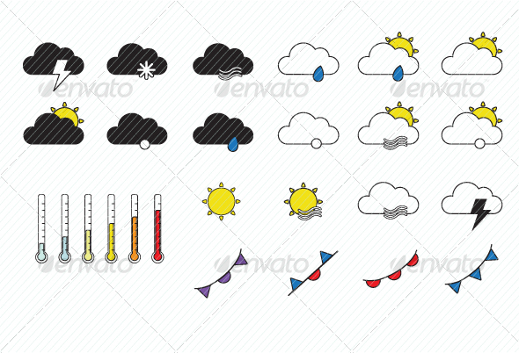

[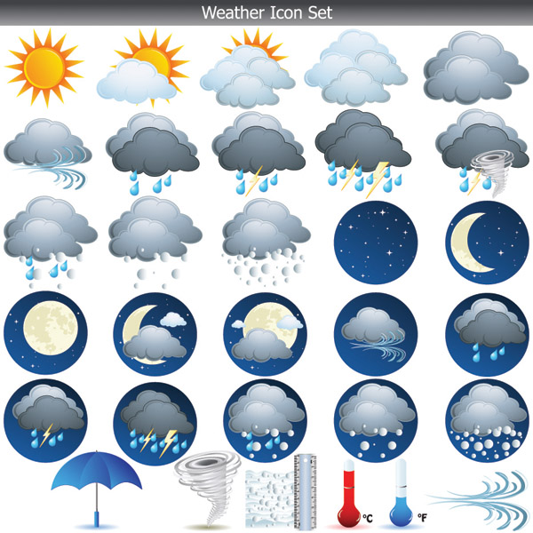](http://www.google.co.uk/url?sa=i&rct=j&q=&esrc=s&frm=1&source=images&cd=&cad=rja&docid=HpqCm_EIJ1xLVM&tbnid=OUitYOvaRws5-M:&ved=0CAUQjRw&url=http%3A%2F%2F4vector.com%2Ffree-vector%2Fweather-icon-vector-19434&ei=qDuaUriqFbCk0AXJ1oHYDg&bvm=bv.57155469,d.ZG4&psig=AFQjCNE00-gdw-7eN_cP6qmmx8bOUeFHSw&ust=1385925871925693)

[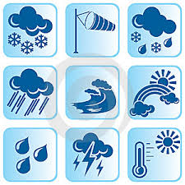](http://www.google.co.uk/url?sa=i&rct=j&q=&esrc=s&frm=1&source=images&cd=&cad=rja&docid=HpqCm_EIJ1xLVM&tbnid=OUitYOvaRws5-M:&ved=0CAUQjRw&url=http%3A%2F%2Fenvironmental-design.co.uk%2Fty-free-download-icon-temperature-vector.phtml&ei=uDuaUqenNMLH0QWNj4DIBg&bvm=bv.57155469,d.ZG4&psig=AFQjCNE00-gdw-7eN_cP6qmmx8bOUeFHSw&ust=1385925871925693)

[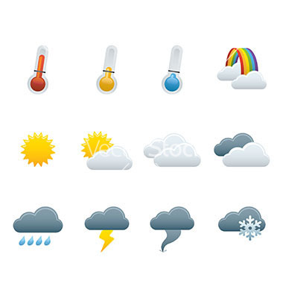](http://www.google.co.uk/url?sa=i&rct=j&q=&esrc=s&frm=1&source=images&cd=&cad=rja&docid=HpqCm_EIJ1xLVM&tbnid=OUitYOvaRws5-M:&ved=0CAUQjRw&url=http%3A%2F%2Fwww.vectorstock.com%2Froyalty-free-vector%2Fweather-forecast-icons-vector-257608&ei=xDuaUrO-O-ib1AXgj4DAAg&bvm=bv.57155469,d.ZG4&psig=AFQjCNE00-gdw-7eN_cP6qmmx8bOUeFHSw&ust=1385925871925693)

[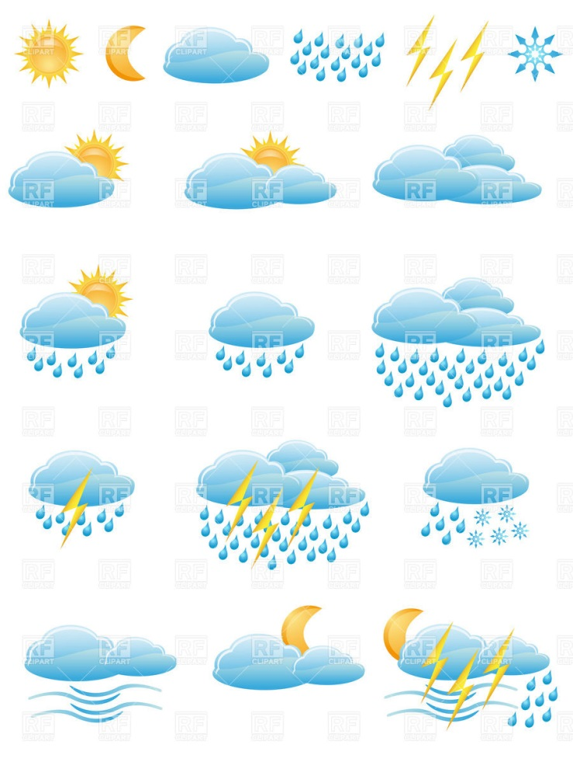](http://www.google.co.uk/url?sa=i&rct=j&q=&esrc=s&frm=1&source=images&cd=&cad=rja&docid=HpqCm_EIJ1xLVM&tbnid=OUitYOvaRws5-M:&ved=0CAUQjRw&url=http%3A%2F%2Frfclipart.com%2Fweather-forecast-and-meteorology-icons-clouds-sun-and-rain-19481-vector-clipart.html&ei=0zuaUuKiENCR0QXMkICQBQ&bvm=bv.57155469,d.ZG4&psig=AFQjCNE00-gdw-7eN_cP6qmmx8bOUeFHSw&ust=1385925871925693)

[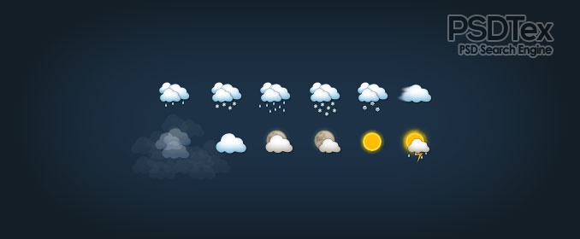](http://www.google.co.uk/url?sa=i&rct=j&q=&esrc=s&frm=1&source=images&cd=&cad=rja&docid=HpqCm_EIJ1xLVM&tbnid=OUitYOvaRws5-M:&ved=0CAUQjRw&url=http%3A%2F%2Fwww.psdtex.com%2Fbeautiful-weather-forecast-icons-psd.html&ei=8DuaUpT7Leib1AXgj4DAAg&bvm=bv.57155469,d.ZG4&psig=AFQjCNE00-gdw-7eN_cP6qmmx8bOUeFHSw&ust=1385925871925693)